Type of the Paper (Article, Review, Communication, etc.)

Occurrence and co-occurrence of mycotoxins in cereals-based feed and food

Roberta Palumbo1, Alfonso Crisci 2, Armando Venâncio 3, Jean-Lou Dorne 4, Piero Toscano 2,* and Paola Battilani 1

1 Department of Sustainable Crop Production (DI.PRO.VE.S.), Faculty of Agriculture, Università Cattolica del Sacro Cuore, Via Emilia Parmense 84, 29100 Piacenza, Italy; paola.battilani@unicatt.it

2 National Research Council, Institute of Biometeorology (IBIMET); p.toscano@ibimet.cnr.it

3 Centre of Biological Engineering (CEB), University of Minho, 4710-057 Braga, Portugal; [avenan@deb.uminho.pt](mailto:avenan@deb.uminho.pt)

4 European Food Safety Authority (EFSA); [jean-lou.dorne@efsa.europa.eu](mailto:jean-lou.dorne@efsa.europa.eu)

**\*** Correspondence: p.toscano@ibimet.cnr.it; Tel.: (optional; include country code; if there are multiple corresponding authors, add author initials) +xx-xxxx-xxx-xxxx (F.L.)

Received: date; Accepted: date; Published: date

**Abstract:** Dietary (co)-exposure to mycotoxins is associated with human and animal health concerns as well as economic losses. This study aims to give an insight on the currently available information in the scientific literature on (co-)occurrence of mycotoxins in cereals-based feed and food**.** An Extensive Literature Search (ELS) was undertaken in order to collect available occurrence and co-occurrence data of mycotoxins (i.e. parent and modified forms) in European core cereals, and to estimate potential pattern of co-exposure in humans and animals. A total number of 8406 records were collected from peer-reviewed literature from 2000-2018. Mycotoxins were mainly reported in wheat and maize showing the highest concentrations of fumonisins (FBs), deoxynivalenol (DON), aflatoxins (AFs), and zearalenone (ZEN). The max concentrations of FB1+FB2 were reported in maize both in feed and food, being above 4,000 μg/kg (legal maximum levels (MLs) in unprocessed maize in the EU) and 1,000 μg/kg (MLs in maize based foods for direct human consumption). Similar results were observed in DON-food, whose max concentrations in wheat, barley, maize and oat exceeded the MLs 750 μg/kg. Co-occurrence was reported in 54.9 % of total records, meaning that they were co-contaminated with at least two mycotoxins. In the context of parental mycotoxins, co-occurrence of DON was frequently observed with FBs in maize and ZEN in wheat; DON+NIV and DON+T2/HT2 were frequently reported in barley and oat, respectively. Apart from the occurrence of ZEN and its phase I and phase II modiﬁed forms only a limited number of quantiﬁed data were available for other modified forms; i.e. mainly the acetyl derivatives of DON.

**Keywords:** maize; wheat; barley, oat; aflatoxin; Fusarium toxins discipline.)

1. Introduction

Mycotoxins are toxic secondary metabolites produced by different genera of filamentous fungi that infect susceptible plants throughout the world [1,2]. These toxins are low molecular weight and very stable compounds likely to contaminate dietary staple foods, particularly cereals, along the entire production chain, especially under conductive pre and post-harvest conditions. Crops may be infected with multiple species of mycotoxigenic fungi, and most fungal strains produce more than one type of mycotoxin. Therefore, co-contamination of agricultural products with multiple mycotoxins is frequently observed and recently stressed [3-6]. When raw materials are mixed to produce feed or processed into food, mycotoxin co-occurrence becomes even more likely. Although potential interventions to prevent field outbreaks have been considered in several crops worldwide [7-11], mycotoxins still represent an important public health and economic burden.

To date over 400 different mycotoxins have been identified with different chemical structures and properties, produced by a range of different fungal species. Among them, there are well characterized groups of mycotoxins such as aflatoxins (AFs), fumonisins (FBs), type A trichothecenes (e.g. T-2 and HT-2 toxin), type B trichothecenes (e.g. deoxynivalenol (DON), nivalenol (NIV)), zearalenone (ZEN), ochratoxin A (OTA), patulin (PAT), ergot alkaloids (EAs) as well as emerging toxins namely citrinin (CIT) and enniatins (ENNs). Noteworthy, many structurally-related congeners, defined as modified mycotoxins are generated by plant, fungi metabolism, or food processing, and coexist with their native forms [12]. As a consequence of their complex and variable chemical structure and ubiquitous presence, humans and animals can be potentially exposed to single or multiple mycotoxins through the consumption of contaminated diets.

Mycotoxins are well established to have a number of health impacts both in humans and animals. Depending on the quantities consumed, mycotoxins and their metabolites are associated with severe acute poisoning, including death, and chronic adverse health effects. The toxicity of several mycotoxins has been demonstrated for single compound. Aflatoxin B1 (AFB1) was classified by the International Agency for Research on Cancer (IARC) as carcinogenic to humans (Group 1) and recognised being one of the most potent liver genotoxic carcinogen known [13]. Fumonisins B1 and B2 (FB1, FB2) and OTA were classified in group 2B, compounds considered carcinogenic to animals and possibly carcinogenic to humans [13]. IARC recently also associated AFs and FBs dietary exposure with high levels of stunting and growth impairment in children.

In addition, interaction effects (i.e. additive, synergistic, or antagonistic) have also been associated with the co-exposure to multi-mycotoxin. However, in the peer-reviewed literature there are still limited papers addressing toxicokinetics (TK) aspects after concurrent exposure to mycotoxins in living organism [14-16].

The effect of feed-borne mycotoxins on food-producing animal performance represents an economic problem for farmers; reduced growth, decreased egg and milk production, lower reproductive efficiency, and increased susceptibility to stress are all consequences of mycotoxin exposure. Moreover, consumers are potentially also exposed indirectly, due to the contamination in foods of animal origin due to carry-over (i.e. milk, eggs, etc.).

The impact of multiple mycotoxins on animal and human health has been recognized by European regulatory bodies as an emerging risk for feed and food safety and security. Efforts to reduce human and animal exposure to mycotoxins resulted in the establishment of regulatory limits and monitoring programme worldwide. Maximum permitted levels (MLs) or guidance of safety levels have been provided in different countries. European legislation protects consumers by setting legal MLs for the main classes of mycotoxins in several core commodities intended for food and feed, like cereals, nuts, fruits and derived products, including milk [17-20]. However, the current MLs do not consider the exposure to multiple mycotoxins and they are either based on the risk assessment of a single compound or on their sum, like the cases of AFs and FBs. According to the European Commission Regulation 1881/2006, and subsequent amendments, the MLs for AFs in cereals intended for direct human consumption is set to 2 µg/kg of AFB1 and 4 µg/kg of the total sum of AFB1, AFB2, AFG1 and AFG2; whereas, the MLs for the sum of FB1 and FB2 is set to 1,000 µg/kg in maize intended for direct human consumption, and 4,000 µg/kg in unprocessed maize [21,22]. In addition, guidance values for the sum of FB1 and FB2 and DON have been recommended in products intended for animal feed in the EU [23].

The conventional exposure assessment paradigm of groups of populations to single mycotoxins utilizes consumption and occurrence data to derive exposure scenarios. In the context of multi-mycotoxins, a rationale way to perform risk assessment is by establishing priorities based either on the realistic frequency of the co-occurring mycotoxins or by considering the potency of the combined toxic effect.

Therefore, monitoring mycotoxin co-occurrence enables identifying the most prevalent mycotoxin mixtures and, thus, can help to prioritize research efforts. Thus, the aim of this paper was to give an insight on the currently available information in the scientific literature on the presence of mycotoxins in cereal-derived feed and food commodities in Europe, and their natural co-occurrence.

2. Materials and Methods

Data collection and data extraction

An Extensive Literature Search (ELS) was undertaken in order to collect available papers in scientific literature on the (co-)occurrence of mycotoxins in core cereals, including maize, wheat, barley, oat, rice, rye, and sorghum from 2010 to 2018, and it was focused on the need of exposure calculations. When necessary, ad hoc searches with extended timeframe (up to 2000) were undertaken, as in the case of maize and sorghum. Mycotoxins with major public health and economic interest were included in the searching criteria, intended as those regulated at European level and their modified forms, plus some emerging mycotoxins. Starting from a substantial initial number of 13026 papers, the screening process resulted in a selection of 206 papers, which were used for data extraction. The following represents the flowchart associated with the selection of studies relevant to the aim of this study (Figure 1).

Since the collection of these data was meant to estimate dietary exposure of humans and animals in Europe, attention was paid to EU data. Although the information on the origin of no-EU imported commodities was stored.

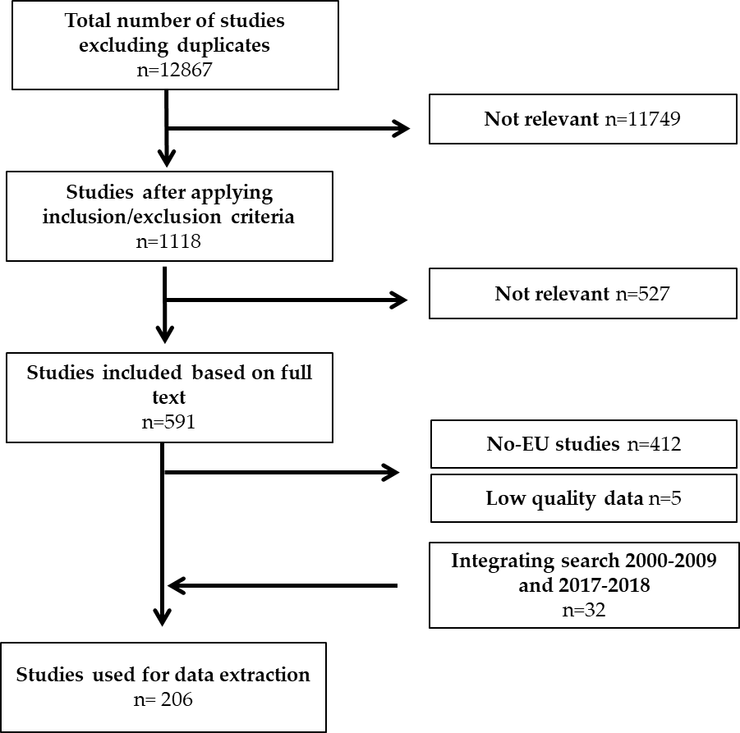

Figure 1. Flow chart of the extensive literature search performed.

Development of a structured database

A database for data collection on mycotoxins occurrence/co-occurrence was structured according to the EFSA Standard Sample Description version 2 (SSD2) standard [24]. SSD2 data model is used to support reporting countries in data submission to EFSA and it is structured to collect analytical results at sample level. In our study, the standard data model was adapted to aggregate data, which is the way authors commonly report occurrence data in the Literature. However, when the co-occurrence data were reported at sample level a univocal identification number (ID) was assigned to each specific sample. A comprehensive description of the individual data elements of the SSD2-based data model is provided in supplementary materials.

Data analysis

A general quali-quantitative description of the ELS records was conducted providing an insight of both occurrence and co-occurrence in EU-countries. Descriptive statistics for concentrations of most frequently occurring mycotoxins and their modified forms in cereal based feed and food, as well as for other study variables, were derived. A qualitative score was implemented for occurrence data while frequency and multinomial distribution analysis were performed for co-occurrence data. Data model and analysis were performed in R environment[1], while all the data and functions are currently available on the MYCHIF project repository[2].

Data occurrence analysis

The database of occurrence and co-occurrence includes 12 crop aggregations: barley, buckwheat, cereals, maize, oat, rice, rye, sorghum, spelt, triticale, wheat and others (millet and soy); often in the case of mixed cereal-grains based commodities, the main ingredients were not indicated. For this reason, ‘cereals’ was kept as one commodity category, intended as mixed cereals. Occurrence data of each mycotoxin, stratified by crop, were extracted and analysed. Only records reporting concentration value (data at sample level) or mean value (aggregate data) were extracted. Values lower than LOD (limit of detection) or lower than LOQ (limit of quantification) were not included in the analysis, but tracked (<LOD = -1; <LOQ = -2) for further processing. Nonlinear regression analysis was applied in order to find out the distribution type that best reflects each mycotoxin-crop dataset block in order to build a reliable reference distribution useful to assess the related risk exposure. Weibull, gamma, lognormal and normal distributions were tested for each data block and the benchmark with empirical data was done by using:

- histogram and theoretical densities plot

- empirical and theoretical Cumulative Distribution Function (CDF) plot

- Quantile-Quantile (Q-Q) plot

- Probability-Probability (P-P) plot

To facilitate the visualization of the quality and quantity of the extracted datasets, measuring the strength of backward bibliographical context, a general score 7 scaled index, named *Scoregen*, was implemented as the sum of 7 partial sub-indices defined below:

$Score_{gen}=Score_{numerosity}+Score_{validity}+CV_{score}+P_{sampleSize}+P_{agePaper}+P_{bibIntensity}+P_{haveBounds}$

where *Score numerosity* refers to data availability (i.e. papers with at least 25 sample data were marked as 1); *Score validity* refers to the percentage of good data available (i.e. normalized mean of valid data given by single paper); *CV score* refers to the coefficient of variation of toxin concentration calculated in records considered; *P sampleSize* refers to the total number of samples in all the records considered with at least 5 valid data; *P agePaper* refers to the age (years from the publication) of papers (i.e. normalized mean age of paper); *P bibIntensity* refers to bibliography intensity ( i.e. normalized records of unique paper), and *P haveBounds* refers to records that provide also statistical information as range (i.e. Min/Max values). Each sub-index is based on data normalized in the range 0-1.

For a general view of *Scoregen* index and all sub-indices for each combination of mycotoxin and crop, heatmap plots were then drawn.

Data co-occurrence analysis

Based on what is clearly stated in each manuscript about the co-occurrence (identified as co-occurrence=1 in the database) of 2 or more mycotoxins on the same sample, the number of co-occurrence cases for each crop was extracted. Within all the data extracted, in this study the focus was on 4 crops (maize, wheat, barley and oat) and 6 main co-occurring mycotoxins and their modified forms (AFs, DON, FBs, NIV, T2+HT2, ZEN) providing a more detailed analysis. Soft wheat and durum wheat were aggregated only for co-occurrence data analysis. Finally, for each crop aggregation and each co-occurrence, average concentrations and the relative frequency of co-occurrence were calculated.

In the context of co-occurrence of native forms, the frequency in which a mycotoxin (i.e. AFs, FBs, etc.) was reported alone or in combination with others was recorded, allowing the identification of patterns of co-occurrence and their frequency in the dataset studied. This was used to fit a multinomial model to estimate the probability that each of the mycotoxin is present in a sample from food or feed. The multinomial model uses the frequencies of each combination of mycotoxin to estimate the probability that a single mycotoxin is present, and this is then used to simulate potential co-occurrence based on the observed patterns reported.

3. Results

A total number of 8406 records and 1440646 samples were collected. The vast majority of the studies reported data from more than one cereal, and the most studied crops were found to be respectively wheat (34 %), maize (28 %), barley (10 %), oat (9 %) and rice (6 %) (Table 1). Buckwheat, rye, triticale, sorghum, spelt and others (millet + soy) account all together for the 7 %, being rye the most studied. Furthermore, ‘cereals’, accounted for the 6 % of total records.

**Table 1.** Total number of records per crop with specification on number of records below the limit of detection, the limit of quantification and co-occurrence studies

|  |  |  |  |  |  |
| --- | --- | --- | --- | --- | --- |
| **Crop/Aggregation** | **N of records**1 | **<LOD**2 | **<LOQ**3 | **N of co-occ studies**4 | **N of co-occ**  **Records**5 |
| Barley | 865 | 140 | 109 | 17 | 330 |
| Buckwheat | 6 | 3 | 0 | 1 | 4 |
| Cereals | 463 | 189 | 61 | 12 | 223 |
| Maize | 2362 | 1055 | 66 | 27 | 1443 |
| Oat | 740 | 150 | 81 | 14 | 374 |
| Rice | 520 | 297 | 26 | 8 | 343 |
| Rye | 236 | 75 | 14 | 10 | 111 |
| Sorghum | 101 | 62 | 9 | 2 | 51 |
| Spelt | 83 | 26 | 1 | 3 | 61 |
| Triticale | 127 | 48 | 0 | 3 | 13 |
| Wheat | 2860 | 1252 | 142 | 43 | 1646 |
| Others **6** | 43 | 32 | 0 | 3 | 13 |
| All | 8406 | 3329 | 509 | 482 | 4612 |

1 Total number of records; 2 Records reported as below the limit of detection; 3 Records reported as below the limit of quantification; 4 Number of co-occurrence studies; 5 Number of co-occurrence records; 6 Millet and soy

Data refer to feed (2225 records), food (4104 records), feed&food (42 records) and cereals with not defined usage (2035 records). The most frequently occurring mycotoxins and modified forms (i.e. number of records above twenty) in feed, food and cereals with not defined usage are displayed in Figure 2, Figure 3 and Figure 4, respectively.

The origin of samples was not always the European country where the study was performed; the data set also contains a limited number of samples originating from Africa, Asia and South America (n= 590 records of which 48 records as mix from different Continents), being rice (34.2 %), wheat (21.9 %), maize (15.8 %), sorghum (13.0 %), barley (3.9 %), cereals (3.7 %), rye (3.6 %); oat (3.1 %) and soy (0.8 %).

The year of publication of the retrieved papers ranged between 2000 and 2018, being the majority of records distributed between 2010-2017; the reduced number of paper observed in 2018 is partly due to the timing of literature searching, (i.e. last access in June 2018) (Figure 2).

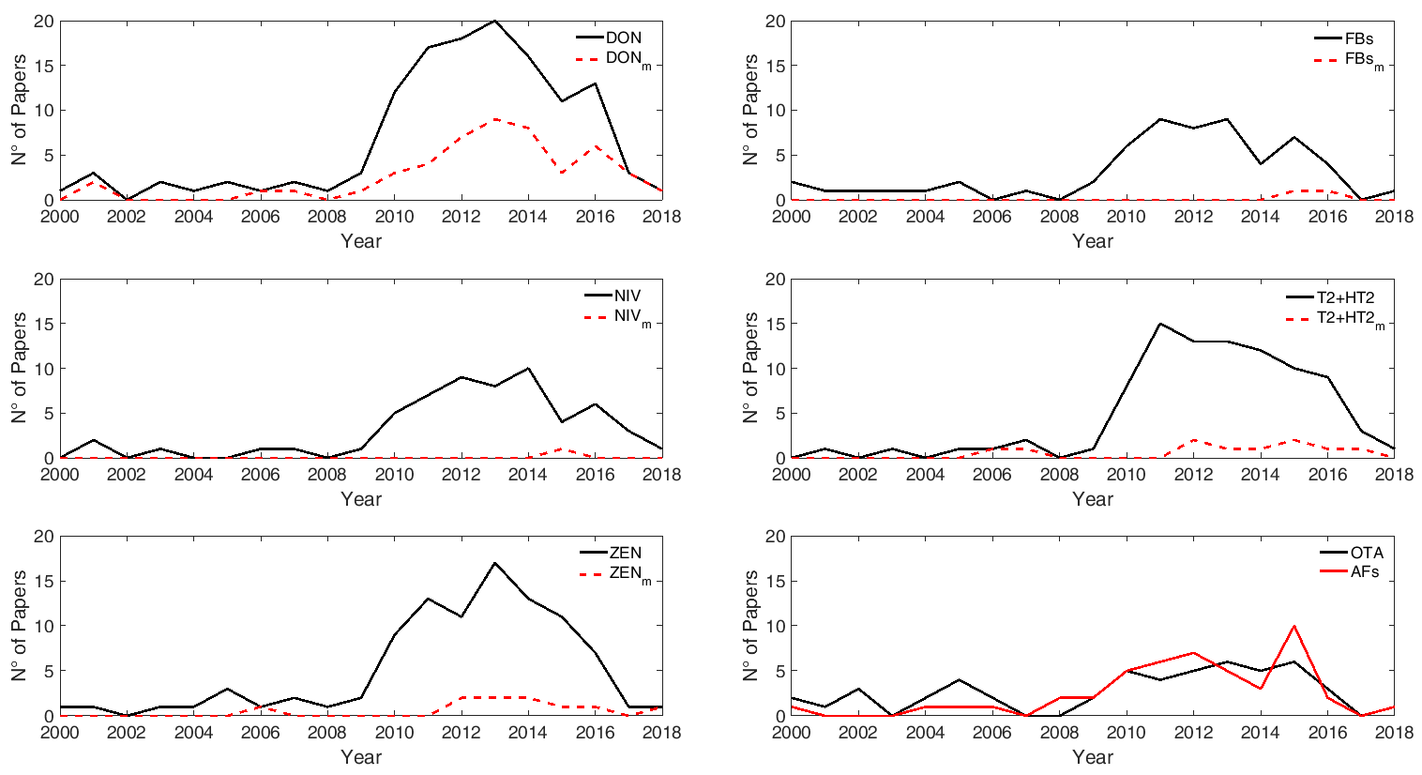

Figure 2: Distribution of records by year of publication. The last update to the search was conducted on June 2018. Solid line refers to parent mycotoxins while dashed lines refer to modified forms. m=modified forms

The proportion of left censored data (LCD), intended as results below LOD (non-detected analytes) or below LOQ (detected but non-quantified analytes), ranged from 39.6 % (<LOD) to 6.0 % (<LOQ) (Table 1). Since these data could be used for a dietary exposure assessment in humans, they were treated by the substitution method [25,26] meaning that, at the lower-bound (LB), all results reported as lower than the LOD were set to zero and to the numerical value of LOD for results reported as lower than LOQ; at the upper-bound (UB), the results below the LOD were set to the numerical value of LOD and to the value of LOQ for results below the LOQ.

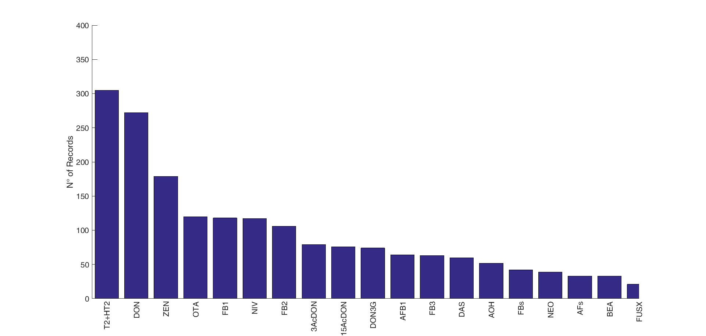

**Figure 3.** Most frequently reported mycotoxins and secondary metabolites in feed in Europe. The figure displays the compounds with a number of records above twenty.

**N>20:** T2: T-2 toxin, HT2: HT-2 toxin, DON: deoxynivalenol, ZEN: zearalenone, OTA: ochratoxin A, FB1: fumonisin B1, NIV: nivalenol, FB2: fumonisin B2, 3Ac-DON: 3-acetyldeoxynivalenol, 15Ac-DON: 15acetyldeoxynivalenol, DON3G: deoxynivalenol-3-glucoside, AFB1: aflatoxin B1, FB3: fumonisin B3, DAS: diacetoxyscirpenol, AOH: alternariol, FBs: total fumonisins, NEO: neosolaniol, AFs: total aflatoxins, BEA: beauvericin, FUS-X: fusarenon-X. **N<20 (not reported in the figure):** HT2-3Glc: HT-2 toxin-3-diglucoside, T2-3Glc: T-2 toxin-3-diglucoside, AFB2: aflatoxin B2, AFG1: aflatoxin G1, AFG2: aflatoxin G2, α-ZEL: α-zearalenol, FB1+FB2: fumonisin B1 + fumonisin B2, AME: alternariol monomethyl ether, STO: scirpentriol, ALTERNARIA: alternaria toxins, β-ZEL: β-zearalenol, STC: sterigmatocystin, CIT: citrinin, ENB: enniatin B, MAS: monoacetoxyscirpenol, T2-tetraol: T2 tetraol, T2-triol: T2 triol, ENA: enniatin A, ENA1: enniatin A1, ENB1: enniatin B1, ENB2: enniatin B2, ALT: altenuene, Ergocornine, Ergocristine, Ergocryptine, AND A: andrastin A, αZEL14G: α-zearalenol-14-glucoside, Marcfortine A, MON: moniliformin, NIV3G: nivalenol-3-glucoside, ROQC: Roquefortine C, β-ZEL14G: β-zearalenol-14-glucoside, TeA: tenuazonic acid, ZEN14G: zearalenone-14-glucoside, ZEN14S: zearalenone-14-sulfate, ZEN16G: zearalenone-16-glucoside.

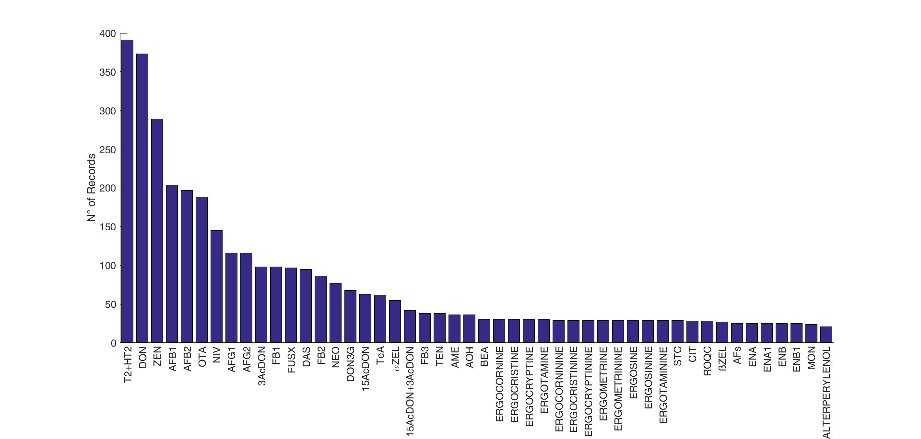

**Figure 4:** Most frequently reported mycotoxins and secondary metabolites in food in Europe. The figure displays the compounds with a number of records above twenty.

**N>20:** T2: T-2 toxin, HT2: HT-2 toxin, DON: deoxynivalenol, ZEN: zearalenone, AFB1: aflatoxin B1, AFB2: aflatoxin B2, OTA: ochratoxin A, NIV: nivalenol, AFG1: aflatoxin G1, AFG2: aflatoxin G2, 3Ac-DON: 3-acetyldeoxynivalenol, FB1: fumonisin B1, FUS-X: fusarenon-X, DAS: diacetoxyscirpenol, FB2: fumonisin B2, NEO: neosolaniol, DON3G: deoxynivalenol-3-glucoside, 15Ac-DON: 15acetyldeoxynivalenol, TeA: tenuazonic acid, α-ZEL: α-zearalenol, FB3: fumonisin B3, TEN: tentoxin, AME: alternariol monomethyl ether, AOH: alternariol, BEA: beauvericin, STC: sterigmatocystin, CIT: citrinin, ROQC: Roquefortine C, β-ZEL: β-zearalenol, AFs: total aflatoxins, ENA: enniatin A, ENA1: enniatin A1, ENB: enniatin B, ENB1: enniatin B1, MON: moniliformin. **N<20 (not reported in the figure):** FB1+FB2: fumonisin B1 + fumonisin B2, αZEL4G: α-zearalenol-4-glucoside, βZEL4G: β-zearalenol-4-glucoside, T2-triol: T2 triol, ZEN4G: zearalenone-4-glucoside, ZEN4S: zearalenone-4-sulfate, ATX1: altertoxin 1, PAT: patulin, ATX2 :Altertoxin 2, AME3G: alternariol monomethyl ether-3-glucoside, AME3S: alternariol monomethyl ether-3-sulfate, AOH3G: alternariol-3-glucoside, AOH3S: alternariol-3-sulfate, FBs: total fumonisins, AOH9G: alternariol-9-glucoside, HFB1: hydrolysed fumonisin B1, FUS: fusaproliferin, MAS: monoacetoxyscirpenol, T2-tetraol: T2 tetraol, ENB4: enniatin B4, STO: scirpentriol, αZEL14G: α-zearalenol-14-glucoside, HT2-3G: HT-2 toxin-3-diglucoside, NIV3G: nivalenol-3-glucoside, β-ZEL14G: β-zearalenol-14-glucoside, ZEN14G: zearalenone-14-glucoside, ZEN14S: zearalenone-14-sulfate, 15OHculmorin: 15-OH Culmorin, 5OHculmorin: 5-OH Culmorin, Culmorin, ENs: enniatins.

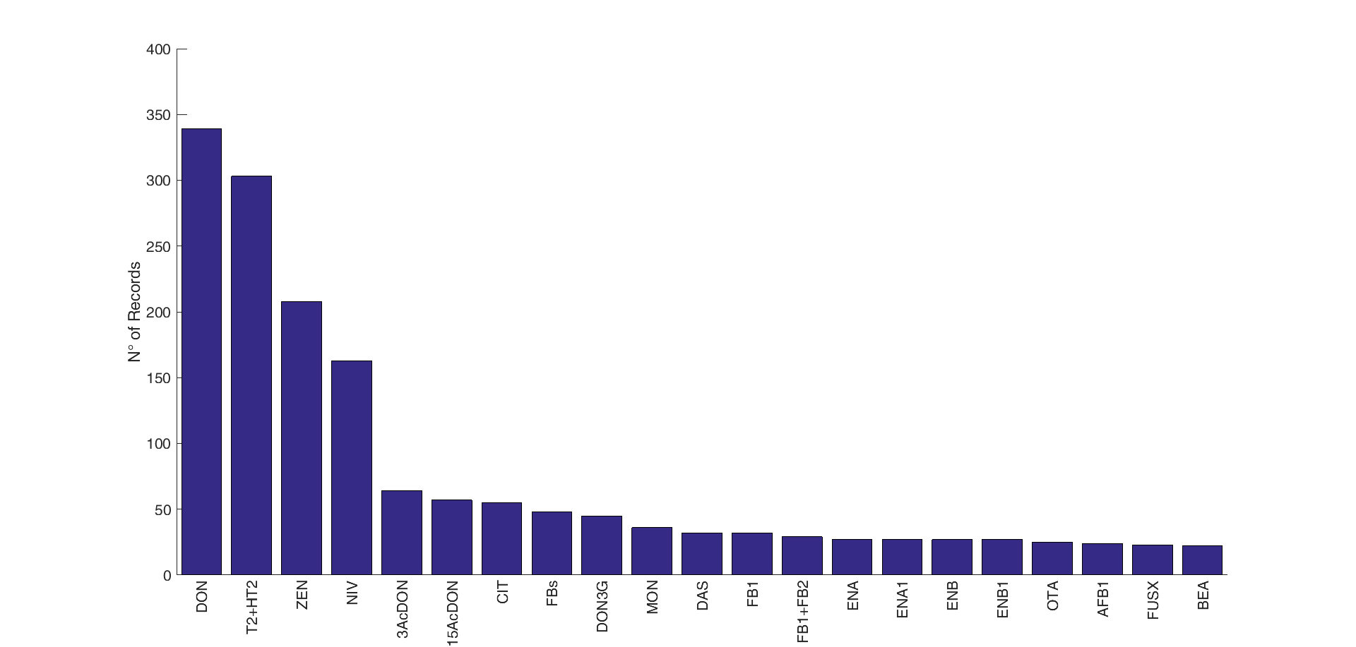

**Figure 5.** Most frequently reported mycotoxins and secondary metabolites in cereals without specification of food and feed in Europe. The figure displays the compounds with a number of records above twenty.

**N>20:** DON: deoxynivalenol, T2: T-2 toxin, HT2: HT-2 toxin, ZEN: zearalenone, NIV: nivalenol, 3Ac-DON: 3-acetyldeoxynivalenol, 15Ac-DON: 15acetyldeoxynivalenol, CIT: citrinin, FBs: fumonisins, DON3G: deoxynivalenol-3-glucoside, MON: moniliformin, DAS: diacetoxyscirpenol, FB1: fumonisin B1, FB1+FB2: fumonisin B1 + fumonisin B2, ENA: enniatin A, ENA1: enniatin A1, ENB: enniatin B, ENB1: enniatin B1, OTA: ochratoxin A, AFB1: aflatoxin B1, FUS-X: fusarenon-X, BEA: beauvericin. **N<20 (not reported in the figure):** T2-tetraol: T2 tetraol, FB2: fumonisin B2, NEO: neosolaniol, T2-triol: T2 triol, AME: alternariol monomethyl ether, AOH: alternariol, β-ZEL: β-zearalenol, STO: scirpentriol, 15Ac-DON: 15acetyldeoxynivalenol, α-ZEL: α-zearalenol, AFB2: aflatoxin B2, AFG1: aflatoxin G1, AFG2: aflatoxin G2, FB3: fumonisin B3, Culmorin: culmorin, ENB2: enniatin B2, HFB1: hydrolysed fumonisin B1, OTB: ochratoxin B, ENs: enniatins, Ergometrine/-metrinine, STC: sterigmatocystin, TeA: tenuazonic acid, TEN: tentoxin, 15OHculmorin: 15-OH Culmorin, 2-AOD-3-ol: 2-Amino-14,16-dimethyloctadecan-3-ol, Ergocryptine/-cryptinine, ATX1: altertoxin 1, Aurofusarin, Avenacein Y, Averufin, ENB3: enniatin B3, Equisetin, Ergocristine/-cristinine, ZEN4S: zearalenone-4-sulfate, Deepoxy HT2, Deepoxy T2, AFs: total aflatoxins, ALT: altenuene.

3.1. Data quality

According to the data quality analysis, maize and wheat were the most studied cereals. With regards to wheat, the majority of data was reported for DON which showed the highest score with a value of 4.12/7. In maize, FB1 showed the highest ranking followed by DON with values of 4.08/7 and 4.06/7, respectively. Overall, DON was among the most reported mycotoxins, ranking first in wheat, barley, cereals and rye. In maize and oat, DON ranked second after FB1 and T2+HT2 toxins, respectively. With regards to rice, data were reported mainly on AF and OTA with a general score ranging between 2.89 and 2.77.

Table 2 reports the range obtained for each sub-index forming the total *Scoregen*. Figure 4 provides a general view of *Scoregen* index and all sub-indices for combinations of mycotoxin and crop with a score higher than 1.4. After applying quality criteria, a final number of 7 crops were selected and used for human exposure assessment to mycotoxins through cereal-based diet.

**Table 2.** Composition of the *Scoregen* index and ranging for each individual sub-index.

|  |  |  |  |  |
| --- | --- | --- | --- | --- |
| **N** | **Sub-indices code** | **Sub-indices meaning** | **Range** | **Normalization** |
| 1 | *Score numerosity* | data availability | 6 – 332 | 0 – 1 |
| 2 | *Score validity* | percentage of good data available | 0 – 100 | 0 – 1 |
| 3 | *CV score* | coefficient of variation of toxin concentration | 0 – 1 | 0 – 1 |
| 4 | *P sampleSize* | total samples number | 1 – 48 | 0 – 1 |
| 5 | *P agePaper* | age of papers | 2001 – 2018 | 0 – 1 |
| 6 | *P bibIntensity* | bibliography intensity | 1 – 215 | 0 – 1 |
| 7 | *P haveBounds* | statistical information | 0 – 1 | 0 – 1 |

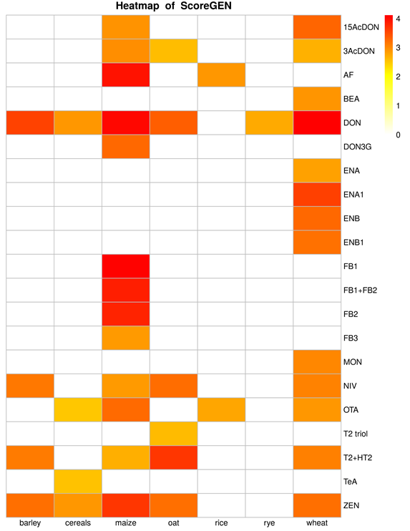

**Figure 6.** *Scoregen* heatmap for mycotoxin-crop with a score higher than 1.4.

3.2. Occurrence of mycotoxins

LB and UB mean concentrations, as well as maximum concentrations (UB), in food and feed are reported by crop in the following paragraphs; more details are available in supplementary tables (Table S.1 to Table S.8).

3.2.2. Wheat

Wheat was the most reported cereal (34 % of total number of records). After maize, wheat was the cereal where the highest concentrations of DON were reported in food (mean LB – UB:

140.1 – 187.9 µg/kg); in feed, almost six times greater mean concentrations were reported (mean LB – UB: 957.7 – 1025.4 µg/kg). 15-Ac-DON ranged from mean concentration (LB) of 6.0 µg/kg in food and 139.1 µg/kg in feed; while 3-Ac-DON ranged from mean concentration (LB) of 8.0 µg/kg in food and 11.9 µg/kg in feed. DON3G was reported only in food (mean LB – UB: 18.1 – 23.6 µg/kg).

The lowest mean concentration of AFB1 was observed in wheat-based food (mean LB – UB: 0.0 – 0.6 µg/kg); however, these concentrations increased in feed (mean LB – UB: 7.4 – 7.6 µg/kg).

Mean concentrations (LB – UB) of ZEN ranged between 24.2 – 27.0 µg/kg in food and 84.6 – 85.7 µg/kg in feed; different modified forms were reported, being α-ZEL and β-ZEL those with the highest mean concentrations.

Wheat was the second cereal with the highest concentration of NIV after oat (mean LB – UB: 54.8 – 75.2 µg/kg in food; mean LB – UB: 58.2 – 79.2 µg/kg in feed), and, together with barley, it was the only cereal in which NIV3G was reported.

With regard to feed, the highest concentration of OTA was reported in wheat (mean LB – UB: 12.7 – 13.4 µg/kg); however, in food the mean concentrations were much lower ranging between 0.5 – 0.8 µg/kg (LB – UB).

3.2.1. Maize

Maize was the second most reported cereal after wheat and the crop where the highest mean concentrations of FB1 were observed, both in food (n=58; mean LB – UB: 540.7 – 541.3 µg/kg; max: 7,878.7 µg/kg) and feed (n=94; mean LB – UB: 1,806.0 – 1,807.1 µg/kg; max: 30,200.0 µg/kg). FB2 and FB3 also showed the highest mean concentrations in maize, ranging between 135.6 – 141.5 µg/kg and 152.6 – 156.2 µg/kg (LB – UB) in food and 610.7 – 612.2 µg/kg and 57.5 – 61.0 µg/kg (LB – UB) in feed, respectively. Overall, FBs were reported mainly individually, and to a lesser extent as the sum of FB1+FB2. Scarce data was reported on modified FBs (i.e. hydrolysed FBs, HFBs) in thermally processed maize (n=6; FBs+HFBs, mean: 570 µg/kg).

DON was also highly reported in maize both in food (n= 59; mean LB – UB: 256.3 – 263.2 µg/kg, max: 2,266.8 µg/kg) and feed (n=196; mean LB – UB: 714.9 – 735.6 µg/kg, max: 9,528.0 µg/kg) together with its acetyl derivatives. Mean concentration of 3-Ac-DON and 15-Ac-DON in feed were respectively 26.1 – 27.1 µg/kg and 87.1 – 88.1 µg/kg (LB-UB); the lowest concentrations were reported in food for 3-Ac-DON (6.2-6.7 µg/kg), whereas 15-Ac-DON was not reported individually in food, but summed with 3-Ac-DON (mean LB – UB: 186.3 – 188.6 µg/kg). DON3G was also reported in maize with much higher concentrations in feed (max: 763.0 µg/kg).

AFs were also among the most reported mycotoxins, being AFB1 the one with highest mean concentrations (n=22; mean LB – UB: 1.9 – 2.2 µg/kg; max: 22.4 µg/kg in food; mean: 9.9 µg/kg; max: 74.8 µg/kg in feed).

Mean concentrations of ZEN ranged between 80.6 – 82.1 µg/kg (LB – UB) in food and 93.3 – 94.9 µg/kg (LB – UB) in feed; α-ZEL and β-ZEL were the only modified forms reported in maize.

With regards to T2+HT2, low concentrations were reported in maize compared to other cereals (n=53; mean LB – UB: 1.8 – 5.4 µg/kg); higher concentrations were reported in feed compared to food products (n=174; mean LB-UB: 44.8 – 49.2 µg/kg). Modified forms were among the most relevant phase I metabolites, namely T2-triol and T2-tetraol, both reported in feed.

Mean concentrations (LB – UB) of NIV ranged between 9.3 – 28.3 µg/kg in food and 190.6 – 210.0 µg/kg in feed; no modified forms were reported.

Finally, mean concentrations (LB – UB) of OTA ranged between 0.3 – 0.6 µg/kg in food and 2.2 – 2.7 µg/kg in feed.

3.2.3. Barley

Barley was the third most reported cereal after wheat and maize (10 % of the total number of records), and it showed among the highest mean concentrations of several classes of mycotoxins. With regards to food, barley showed higher mean concentrations of ZEN (n=19; mean LB – UB: 26.3 – 26.4 µg/kg, max: 192.0 µg/kg), OTA (n=6; mean LB – UB: 1.0 – 1.1 µg/kg, max: 5.6 µg/kg) and T2+HT2 (n=48; mean LB – UB: 27.3 – 30.8 µg/kg, max: 264.0 µg/kg), compared to other crops, and ranking second after maize, rice and oat, respectively. Barley ranked third with regards to DON in food products (n=22; mean: 173.8 µg/kg, max: 2029.0 µg/kg); 15-Ac-DON, 3-Ac-DON and DON3G were also reported. In particular, the highest mean concentrations of DON3G among all cereals were reported in barley in food (n=5; mean: 109.2 µg/kg, max: 390.0 µg/kg) (when LB – UB is not specified, it meant that the difference between LB and UB concentrations is not perceptible). Whereas, a reduced number of records was retrieved in feed (n=3) with a mean concentration of 413.7 µg/kg; DON3G was not reported in feed. High mean concentration were also observed for FB1 and FB2, both in food and feed; however, this information was obtained from one single record. Barley reported high concentrations of NIV in food (n=16; mean LB – UB: 35.2 – 40.2 µg/kg), ranking third after oat and wheat; NIV3G was reported in one record (25.2 µg/kg). Information on NIV in feed were not retrieved.

3.2.4. Oat

The highest concentrations of NIV were reported in oat, both in food (n=3; mean LB – UB: 81.4 – 86.3 µg/kg) and feed (mean LB – UB: 263.3 – 280.0 µg/kg). FB1 and FB2 were reported only in two records respectively one in food (FB1: 0.1 µg/kg; FB2: 0.5 µg/kg) and one in feed (FB1: 30.0 µg/kg; FB2: 28.0 µg/kg). DON ranked first among other cereals in feed (n=6; mean: 1,309.7 µg/kg, max: 2,690.0 µg/kg), and it was reported also in food with much lower concentrations (n= 31; mean LB – UB: 130.6 – 132.6 µg/kg, max: 1230.0 µg/kg). Modified forms of DON were also reported; mean concentrations of 3-Ac-DON were higher than 15-Ac-DON both in food (mean LB – UB: 28.5-30.6 µg/kg; mean LB – UB: 6.6-10.8 µg/kg) and feed (mean LB – UB: 127.0 – 139.5 µg/kg; mean LB-UB: 24.5 – 49.5 µg/kg). DON3G showed high concentrations in feed (n=2; mean: 711.0 µg/kg). Scarce information was retrieved on AFs both in food and feed; AFB1, AFB2, AFG1 and AFG2 were reported in food only in 2 records, whereas in feed only one record reported AFB1. It should be noted that the highest concentrations of T2+HT2 were reported in oat both in food (n=65; mean LB – UB: 179.9 – 182.5 µg/kg) and feed (n=17; mean LB – UB: 88.1 – 96.9 µg/kg).

3.2.5. Rice

The majority of data retrieved on rice regarded food commodities where the highest mean concentrations of AFB1 (n=124; mean LB – UB: 3.1 – 3.3 µg/kg; max: 91.7 µg/kg) and OTA (n=44; mean: 2 µg/kg in food) were reported. Low mean concentrations of FB1 (n=3; mean LB – UB: 0.0 – 8.4 µg/kg; max: 12.5 µg/kg), FB2 (n=1; mean LB – UB: 0.0 – 0.5 µg/kg; max: 0.5 µg/kg), DON (n=22; mean LB – UB: 7.9 – 15.6 µg/kg; max: 96.0 µg/kg), T2+HT2 (n=14; mean LB – UB: 0.0 – 8.9 µg/kg; max: 60.0 µg/kg) and ZEN (n=7; mean LB – UB: 0.0 – 6.6 µg/kg; max: 10.1 µg/kg) were reported. No information was retrieved on modified forms in rice except for 3-Ac-DON reported in four records with mean ranging (LB – UB) between 0.0 and 0.6 µg/kg. Five records were also reported on NIV (mean LB – UB: 0.0 – 16.0 µg/kg; max 75.0 µg/kg). In feed, only two mycotoxins were reported, namely DON and T2+HT2.

3.2.6. Rye

Overall, scarce information was available on rye compared to other cereals; the number of records ranged between 1 and 18 and the majority of data retrieved was on food commodities. It could be emphasised that rye showed the highest mean concentration of OTA (mean LB – UB: 0.8 – 0.9 µg/kg) however this information derived from a limited number of records (n=5). DON was reported both in food (n=11; mean LB – UB: 55.9 – 56.8 µg/kg) and feed (n=2; mean: 56.2 µg/kg). Whereas 15-Ac-DON (n=2; mean LB – UB: 0.5 – 3.0 µg/kg) and 3-Ac-DON (n=5; mean LB – UB: 8.6 – 13.6 µg/kg) were reported only in food.

3.3. Co-occurrence of mycotoxins

The main co-occurring mycotoxins were analysed by crop category. The analysis of the data quality led to the identification of five suitable crop categories, namely maize, wheat, oat, barley and cereals. The latter was often reported even if the composition and/or the percentages of ingredients were not always indicated by the authors. However, considering that the consumption of mixed cereal-grains based commodities is also one of the causes of the natural co-occurrence of mycotoxins both in animal and human diets, this information was kept.

Several surveys reported the natural co-occurrence of mycotoxins, and most of them concerned DON, OTA, NIV, ZEN, and T2+HT2. Less data was found for AFs, ENs and *Alternaria* toxins.

For each crop aggregation and each co-occurrence, average concentrations and relative frequency of occurrence were then calculated. Figure 7 and Figure 8 show co-occurrence concentrations and relative data frequency for maize and wheat, respectively. Plots prepared for other crops are currently available on the MYCHIF project repository.

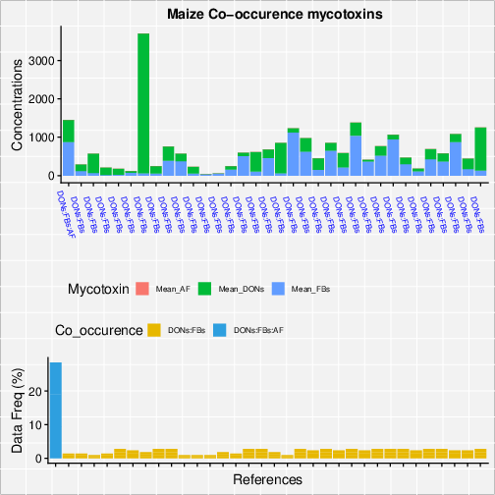

Figure 7. Co-occurrence concentrations and relative data frequencies for maize

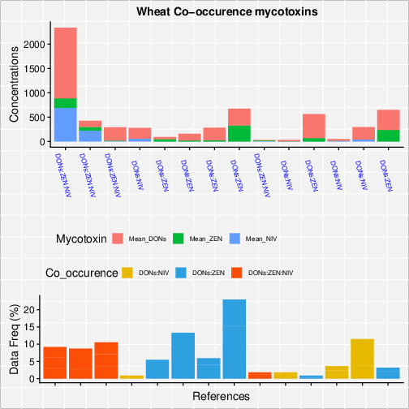

Figure 8. Co-occurrence concentrations and relative data frequencies for wheat

3.3.1. Results of multinomial analysis

The multinomial analysis led to a simulating model that mimic the potential co-occurrence of two or more mycotoxins based on the observed patterns reported in the Literature. Figure 9 shows the number and type of observed patterns of co-occurrence of native mycotoxins in barley, maize, oat and wheat. The proportions reported below provide the probability that each mycotoxin is present in a sample given that the other mycotoxins are present (e.g. in barley, DON has 48.2 % probability to occur in a sample given that NIV and ZEN are present). In addition, the coefficient from the model would say more about the relative risk of having one mycotoxin vs the other one; by calculating the relative odd of two mycotoxins the interpretation would be that when this odd is close to one, it means that the relative risk is the same, thus any of the two could be present in the sample, when is a value larger than 1 tell you that one is more likely to be present than the baseline one, and a value smaller than one means that the likelihood of the baseline mycotoxin is larger than the one in the numerator.

**MAIZE**

DON FB AF COUNT %

1 0 1 0 0.107 10,7%

2 0 1 1 0.005 0,5 %

3 1 0 0 0.131 13,1 %

4 1 0 1 0.003 0,3 %

5 1 1 0 0.744 74,4 %

6 1 1 1 0.01 1,0 %

Il modello simula le probabilità di trovare una micotossina da sola o in combinazione con altre. La probabilità simulata nel mais più alta è di trovare DON+FB (74 %), seguita da DON da solo (13%) e FB da sole (10%); FB+AF (0,5 %), DON+AF (0,3 %). La probabilità stimata di trovarle tutte e tre è 1 %.

**BARLEY**

DON NIV ZEN COUNT %

1 0 0 1 0.013 1,3%

2 0 1 0 0.008 0,8%

3 0 1 1 0.045 4,5%

4 1 0 0 0.205 20,5%

5 1 0 1 0.329 32,9%

6 1 1 0 0.258 25,8%

7 1 1 1 0.142 14,2%

**OAT**

DON T2_HT2 NIV COUNT

1 0 0 1 0.03

2 0 1 0 0.05

3 0 1 1 0.223

4 1 0 0 0.03

5 1 0 1 0.188

6 1 1 0 0.254

7 1 1 1 0.225

**WHEAT**

DON NIV ZEN COUNT

1 0 0 1 0.027

2 0 1 0 0.002

3 0 1 1 0.05

4 1 0 0 0.181

5 1 0 1 0.461

6 1 1 0 0.15

7 1 1 1 0.129

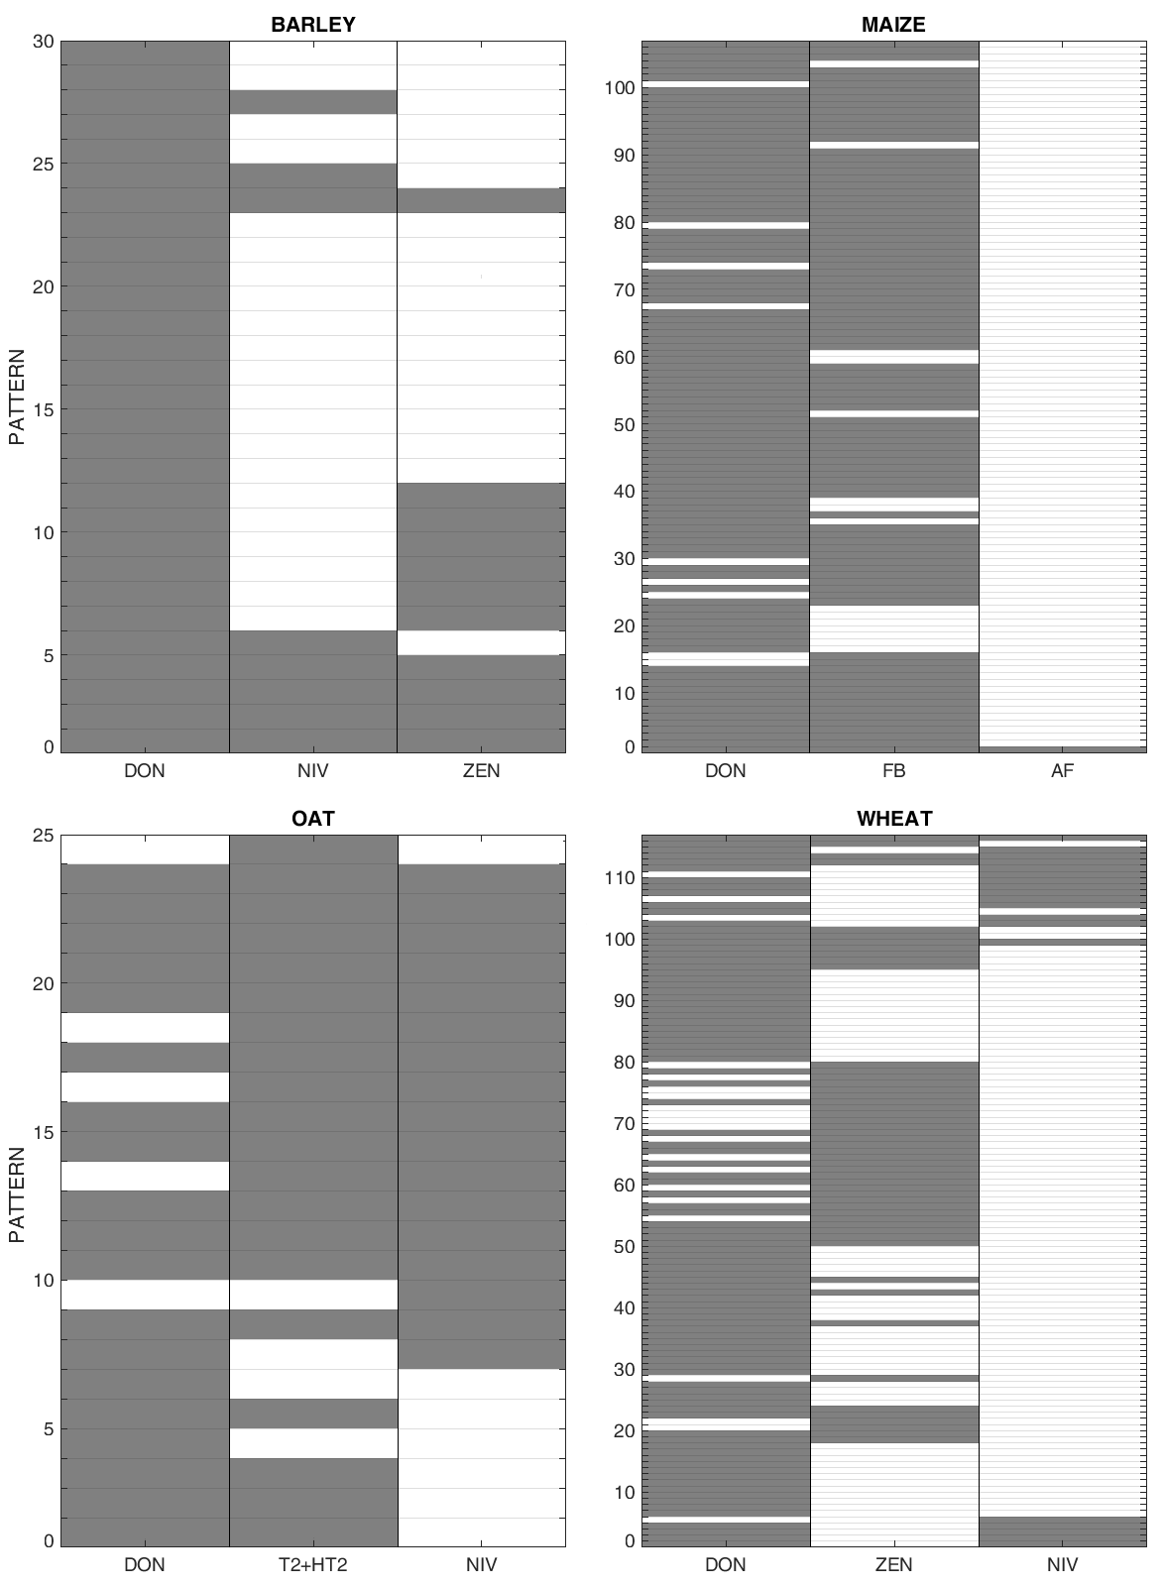

Figure 9. Total number of observations with specific pattern of co-occurrence. Grey and white boxes display the presence and absence of mycotoxin, respectively.

4. Discussion

Cereals are often contaminated by a wide range of mycotoxins and other fungal metabolites. Unsurprisingly, wheat and maize were the most reported cereals showing the highest concentrations of FBs, DON, AFs and ZEN.

FBs were widely reported in maize foods and feed where the max concentrations of FB1+FB2 exceeded the legal maximum levels (MLs) of 1,000 μg/kg and 4,000 μg/kg, respectively [27].

In the context of food, the max concentrations of DON in barley, maize, oat and wheat exceeded the legal limits of 750 μg/kg [27,28]; however, when looking at mean concentrations, none of the cereals showed very high concentrations. Similar results were observed in feed except that max concentrations in barley did not exceed the MLs of 1,250 μg/kg, in contrast to maize, oat and wheat [27,28].

In line with pre-existing knowledge, maximum concentrations of T2+HT2 were particularly high in oat and oat-containing foods, exceeding the MLs of 200 μg/kg [19].

AFs were predominately reported in rice and maize as a result of a pre- and postharvest colonization of the grains with *A. ﬂavus* [7]. In addition, in rice high concentration of OTA were also reported in food, exceeding the legal limits of 3.0 μg/kg [21]. This result is in agreement with prior knowledge, being rice contaminated with the OTA-producer *Aspergillus ochraceus*.

Contamination with NIV was more relevant in oat, wheat and barley, however, neither for NIV nor for its metabolites, MLs have been set in the current regulation [21].

Concerning the occurrence of native forms, DON, FBs and ZEN showed the highest simulated potential co-occurrence value, and in particular, DON was more probable to be found in co-occurrence with FBs in maize and with ZEN in wheat. This ﬁnding is consistent with the results of a recent study conducted on Canadian cereal samples where the co-occurrence of DON and other *Fusarium* mycotoxins was frequently observed in wheat and barley [29].

With regards to the occurrence of modiﬁed forms, overall, more data are reported in food compared to feed. Apart from the occurrence of ZEN and its phase I and phase II modiﬁed forms only a limited number of quantitative data are available for other modified forms; i.e. acetyl derivatives of DON; hydrolysed FBs; phase I metabolites of T2, and NIV3G. Overall, data are still scarcely and unevenly reported regardless of an increased awareness of the importance of modified forms on the total toxic effect.

To summarize, it can be highlighted that wheat and maize may potentially contribute more to the human and animal co-exposure to mycotoxins compared to other crops. The results indicate that mycotoxin co-occurrence is common in European cereal-based feed and food, and that it is very important to further conduct multi-mycotoxin monitoring. However, still scarce information is available for the co-occurrence of mycotoxins, as well as for the co-occurrence of modified forms of the native mycotoxin. Further scientific effort is necessary to identify possible combinations of mixtures that can really occur in the real world as well as to better understand the interaction between mycotoxins and its modulation of final toxic effects.

5. Conclusions

Cereals and their processed food products are frequently contaminated with mycotoxins, and co-occurrence of *Fusarium* mycotoxins is highly reported in main cereals, especially wheat, maize, barley and oat. However, there is still limited knowledge on the presence and co-occurrence of multiple mycotoxins, both in term of different native mycotoxins and of native plus modified forms, in food and feed. Therefore, the challenge of depicting realistic pattern of co-exposure in humans and animals remains. To bring forward the risk assessment of mycotoxin mixture, the refinement of assessment factors to determine safe level of exposure is needed, and the following is recommended:

1. The necessity of continuous monitoring of the major mycotoxins in different agricultural commodities and the creation of harmonised methods for generating accurate (co)occurrence data is strongly suggested. This is mandatory to provide a consistent and coherent background of data for risk modelling from which prioritisation criteria of mycotoxin mixtures to be investigated may be derived;
2. LOD/LOQ vary significantly across studies, as well as across measurements in relation to the mycotoxin and the analytical method used. It is known that the degree of LCD in the dataset has a large impact on the uncertainty of the exposure assessment; this uncertainty is further magniﬁed when assessing exposure to multiple chemical substances. Thus, a more harmonise approach should be adopted to reduce this source of uncertainty but also to allow the usability of published data that, currently, in some cases are unusable (e.g. authors reporting range of LOD/LOD across different class of mycotoxins);
3. More accurate reporting of geographical information of the samples could also optimise the efforts to better understand and mapping of mycotoxin problem in EU.

In this context, this article provides a source of ready-to-use data for the implementation of exposure assessment.

**Supplementary Materials:** The following are available online at www.mdpi.com/xxx/s1, Table S1: Occurrence and co-occurrence of DON and secondary metabolites (μg/kg) for Barley, Cereals, Maize, Oat, Rice, Rye and Wheat for feed and food products; Table S2: Occurrence and co-occurrence of FB and secondary metabolites (μg/kg) for Barley, Cereals, Maize, Oat, Rice, Rye and Wheat for feed and food products; Table S3: Occurrence and co-occurrence of AF and secondary metabolites (μg/kg) for Barley, Cereals, Maize, Oat, Rice, Rye and Wheat for feed and food products; Table S4 a: Occurrence and co-occurrence of ZEN and secondary metabolites (μg/kg) for Barley, Cereals, Maize, Oat, Rice, Rye and Wheat for food products; Table S4 b: Occurrence and co-occurrence of ZEN and secondary metabolites (μg/kg) for Barley, Cereals, Maize, Oat, Rice, Rye and Wheat for feed products. Table S5: Occurrence and co-occurrence of T2-HT2 and secondary metabolites (μg/kg) for Barley, Cereals, Maize, Oat, Rice, Rye and Wheat for feed and food products; Table S6: Occurrence and co-occurrence of NIV, NIV3G and OTA (μg/kg) for Barley, Cereals, Maize, Oat, Rice, Rye and Wheat for feed and food products.

**Author Contributions:** Conceptualization, X.X. and Y.Y.; methodology, X.X.; software, X.X.; validation, X.X., Y.Y. and Z.Z.; formal analysis, X.X.; investigation, X.X.; resources, X.X.; data curation, X.X.; writing—original draft preparation, R.P..; writing—review and editing, X.X.; visualization, X.X.; supervision, X.X.; project administration, X.X.; funding acquisition, Y.Y.

**Funding:** Please add: “This research received no external funding” or “This research was funded by NAME OF FUNDER, grant number XXX” and “The APC was funded by XXX”. Check carefully that the details given are accurate and use the standard spelling of funding agency names at https://search.crossref.org/funding, any errors may affect your future funding.

**Acknowledgments:** This review was prepared as part of MYCHIF EFSA project (GP/EFSA/AFSCO/2016/01). Roberta Palumbo carried out this work within the PhD school Agrisystem of Università Cattolica del Sacro Cuore (Italy).

**Conflicts of Interest:** The authors declare no conflict of interest.

References

1. Gruber-Dorninger, C.; Jenkins, T.; Schatzmayr, G. Global mycotoxin occurrence in feed: A ten-year survey. *Toxins* **2019**, *11*, 375.

2. Ingenbleek, L.; Sulyok, M.; Adegboye, A.; Hossou, S.E.; Koné, A.Z.; Oyedele, A.D.; Kisito, K.J.C.S.; Dembélé, Y.K.; Eyangoh, S.; Verger, P., et al. Regional Sub-Saharan Africa total diet study in Benin, Cameroon, Mali and Nigeria reveals the presence of 164 mycotoxins and other secondary metabolites in foods *Toxins* **2019**, *11*, doi:10.3390/toxins11010054.

3. EFSA. Risks for animal health related to the presence of zearalenone and its modiﬁed forms in feed. *EFSA Journal* **2017**, *15*, 4851, doi:10.2903/j.efsa.2017.4851.

4. EFSA. Risks to human and animal health related to the presence of deoxynivalenol and its acetylated and modiﬁed forms in food and feed. *EFSA Journal* **2017**, *5*, 4718, doi:10.2903/j.efsa.2017.4718.

5. EFSA. Risks for animal health related to the presence of fumonisins, their modiﬁed forms and hidden forms in feed. *EFSA Journal* **2018**, *16*, 5242, doi:10.2903/j.efsa.2018.5242.

6. Grenier, B.; Oswald, I.P. Mycotoxin co-contamination of food and feed: meta-analysis of publications describing toxicological interactions. *Mycotoxin Journal* **2011**, 10.3920/WMJ2011.1281, doi:10.3920/WMJ2011.1281.

7. Gonçalves, A.; Gkrillas, A.; Dorne, J.L.; Dall'Asta, C.; Palumbo, R.; Lima, N.; Battilani, P.; Venâncio, A.; Giorni, P. Pre‐ and postharvest strategies to minimize mycotoxin contamination in the rice food chain. *Comprehensive Reviews in Food Science and Food Safety* **2019**, *18*, 441-454, doi:10.1111/1541-4337.12420.

8. Gonçalves, A.; Palumbo, R.; Guimarães, A.; Gkrillas, A.; Dall’Asta, C.; Dorne, J.L.; Battilani, P.; Venâncio, A. The route of mycotoxins in the grape food chain. *American Journal of Enology and Viticulture*.

9. Palumbo, R.; Gonçalves, A.; Gkrillas, A.; Logrieco, A.; Dorne, J.L.; Dall’Asta, C.; Venâncio, A.; Battilani, P. Mycotoxins in maize: mitigation actions with a chain management approach. *Phytopathologia Mediterranea*.

10. Torres, A.M.; Barros, G.G.; Palacios, S.A.; Chulze, S.N.; Battilani, P. Review on pre- and post - harvest management of peanuts to minimize aflatoxin contamination. *Food Research International* **2014**, *62*, 11-19.

11. Torres, A.M.; Palacios, S.A.; Yerkovich, N.; Palazzini, J.M.; Battilani, P.; Leslie, J.F.; Logrieco, A.F.; Chulze, S.N. Fusarium Head Blight and mycotoxins in wheat: Prevention and control strategies across the food chain. *World Mycotoxin Journal World Mycotoxin Journal* **2019**, *in press*, 1-24, doi:10.3920/WMJ2019.2438.

12. Rychlik, M.; Humpf, H.U.; Marko, D.; Danicke, S.; Mally, A.; Berthiller, F.H.; Lorenz, N. Proposal of a comprehensive definition of modified and other forms of mycotoxins including “masked” mycotoxins. *Mycotoxin Research* **2014**, *30*, 197–205, doi:10.1007/s12550-014-0203-5.

13. IARC, I.A.f.R.o.C. Agents Classifed by the IARC Monographs Volumes 1–124. Availabe online: file:///C:/Users/palumro/Downloads/Agents%20Classified%20by%20the%20IARC%20Monographs,%20Volumes%201%E2%80%93124.pdf (accessed on 30 August 2019).

14. Fremy, J.M.; Alassane-Kpembi, I.; Oswald, I.P.; Cottrill, B.; Van Egmond, H.P. A review on combined effects of moniliformin and co-occurring Fusarium toxins in farm animals. *World Mycotoxin Journal* **2019**, *12*, 1-12, doi:10.3920/WMJ2018.2405.

15. Gkrillas, A.; Terciolo, C.; Neves, M.; Palumbo, R.; Dorne, J.L.; Battilani, P.; Oswald, I.P.; Dall’Asta, C. Comparative Toxicokinetics of mycotoxins, alone or in combination in different animal species: a review. *Food and Chemical Toxicology*.

16. Steinkellner, H.; Binaglia, M.; Dall'Asta, C.; Gutleb, A.C.; Metzler, M.; Oswald, I.P.; Parent-Massin, D.; Alexander, J. Combined hazard assessment of mycotoxins and their modified forms applying relative potency factors: Zearalenone and T2/HT2 toxin. *Food and Chemical Toxicology* **2019**, *131*, doi:10.1016/j.fct.2019.110599.

17. European Commission. Regulation (576/2006) on the presence of deoxynivalenol, zearalenone, ochratoxin A, T-2 and HT-2 and fumonisins in products intended for animal feeding. *Official Journal of the European Union* **2006**, *229*, 7-9.

18. European Commission. Regulation (574/2011) amending Annex I to Directive 2002/32/EC of the European Parliament and of the Council as regards maximum levels for nitrite, melamine, Ambrosia spp. and carry-over of certain coccidiostats and histomonostats and consolidating Annexes I and II thereto. *Official Journal of the European Union* **2011**, *159*, 7-23.

19. European Commission. Recommendations (165/2013) on the presence of T-2 and HT-2 toxin in cereals and cereal products. *Official Journal of the European Union* **2013**, *91*, 12-15.

20. European Commission. Commission Recommendation (EU) 2016/1319 of 29 July 2016 amending Recommendation 2006/576/EC as regards deoxynivalenol, zearalenone and ochratoxin A in pet food. **2016**, 58–60.

21. European Commission. Regulation (1881/2006) setting maximum levels for certain contaminants in foodstuffs. *Official Journal of the European Union* **2006**, *36*, 4-24.

22. European Commission. Commission Regulation (EU) No 165/2010 of 26 February 2010 amending Regulation (EC) No 1881/2006 setting maximum levels for certain contaminants in foodstuffs as regards aflatoxins. *Official Journal of the European Union* **2010**, *50*, 8-12.

23. Commission, E. Recommendation 2006/576/EC on the presence of deoxynivalenol, zearalenone, ochratoxin A, T-2 and HT-2 and fumonisins in products intended for animal feeding *Official Journal of the European Union* **2006**, *229*, 7-9.

24. EFSA. Standard Sample Description ver. 2.0. *EFSA Journal* **2013**, *11*, 3424, doi:10.2903/j.efsa.2013.3424.

25. WHO. Assessment of combined exposures to multiples chemicals: report of a WHO/IPCS International Workshop. **2009**.

26. EFSA. Management of left-censored data in dietary exposure assessment of chemical substances. *EFSA Journal* **2010**, *8*, 1557, doi:10.2903/j.efsa.2010.1557.

27. European Commission. Regulation (1126/2007) amending Regulation (EC) No 1881/2006 setting maximum levels for certain contaminants in foodstuffs as regards Fusarium toxins in maize and maize products. *Official Journal of the European Union* **2007**, *255*, 14-17.

28. European Commission. Regulation (1881/2006) setting maximum levels for certain contaminants in foodstuffs. *Official Journal of the European Union* **2006**, *364*, 4-24.

29. Shi, H.; Schwab, W.; Yu, P. Natural Occurrence and Co-Contamination of Twelve Mycotoxins in Industry-Submitted Cool-Season Cereal Grains Grown under a Low Heat Unit Climate Condition. *Toxins* **2019**, *11*, doi:10.3390/toxins11030160.

|  |  |
| --- | --- |
| copyRight | © 2019 by the authors. Submitted for possible open access publication under the terms and conditions of the Creative Commons Attribution (CC BY) license (http://creativecommons.org/licenses/by/4.0/). |

**Table S1.** Occurrence and co-occurrence of DON and secondary metabolites (μg/kg) for Barley, Cereals, Maize, Oat, Rice, Rye and Wheat for feed and food products.

|  |  |  |  |  |  |  |  |  |  |  |  |  |  |  |
| --- | --- | --- | --- | --- | --- | --- | --- | --- | --- | --- | --- | --- | --- | --- |
|  |  |  | **FOOD** | | | | | | **FEED** | | | | | |
| **15AcDON** | **15+3AcDON** | **3AcDON** | **AcDONs** | **DON** | **DON3G** | **15AcDON** | **15+3AcDON** | **3AcDON** | **AcDONs** | **DON** | **DON3G** |
| **Barley** | **N** |  | 5 | 4 | 6 | 1 | 22 | 5 | 1 |  | 1 |  | 3 |  |
| **Mean Conc** | **LB** | 19.6 | 0.3 | 22.3 | 0.0 | 173.8 | 109.2 | 0.0 |  | 0.0 |  | 413.7 |  |
| **UB** | 21.6 | 1.0 | 26.7 | 0.0 | 173.8 | 109.2 | 50.0 |  | 50.0 |  | 413.7 |  |
| **Max Conc** | **UB** | 97.0 | 1.0 | 120.0 | 0.0 | 2029.0 | 390.0 | 50.0 |  | 50.0 |  | 600.0 |  |
| **Cereals** | **N** |  | 17 |  | 24 |  | 21 | 6 |  |  |  |  | 2 |  |
| **Mean Conc** | **LB** | 9.3 |  | 14.3 |  | 46.9 | 22.8 |  |  |  |  | 543.0 |  |
| **UB** | 13.1 |  | 17.4 |  | 50.1 | 24.2 |  |  |  |  | 543.0 |  |
| **Max Conc** | **UB** | 119.0 |  | 130.0 |  | 132.1 | 29.0 |  |  |  |  | 884.0 |  |
| **Maize** | **N** |  |  | 15 | 5 |  | 59 | 15 | 51 |  | 51 | 2 | 196 | 72 |
| **Mean Conc** | **LB** |  | 186.3 | 6.2 |  | 256.3 | 0.0 | 87.1 |  | 26.1 | 108.0 | 714.9 | 112.1 |
| **UB** |  | 188.6 | 6.7 |  | 263.2 | 5.3 | 88.1 |  | 27.1 | 110.5 | 735.6 | 117.0 |
| **Max Conc** | **UB** |  | 808.1 | 31.0 |  | 2266.8 | 5.3 | 1047.0 |  | 339.0 | 211.0 | 9528.0 | 763.0 |
| **Oat** | **N** |  | 21 |  | 24 |  | 31 | 6 | 2 |  | 4 |  | 6 | 2 |
| **Mean Conc** | **LB** | 6.6 |  | 28.5 |  | 130.6 | 34.2 | 24.5 |  | 127.0 |  | 1309.7 | 711.0 |
| **UB** | 10.8 |  | 30.6 |  | 132.6 | 36.8 | 49.5 |  | 139.5 |  | 1309.7 | 711.0 |
| **Max Conc** | **UB** | 27.0 |  | 116.0 |  | 1230.0 | 97.0 | 50.0 |  | 341.0 |  | 2690.0 | 806.0 |
| **Rice** | **N** |  |  |  | 4 |  | 22 |  |  |  |  |  | 1 |  |
| **Mean Conc** | **LB** |  |  | 0.0 |  | 7.9 |  |  |  |  |  | 800.0 |  |
| **UB** |  |  | 0.6 |  | 15.6 |  |  |  |  |  | 800.0 |  |
| **Max Conc** | **UB** |  |  | 0.6 |  | 96.0 |  |  |  |  |  | 800.0 |  |
| **Rye** | **N** |  | 2 |  | 5 |  | 11 |  |  |  |  |  | 2 |  |
| **Mean Conc** | **LB** | 0.5 |  | 8.6 |  | 55.9 |  |  |  |  |  | 56.2 |  |
| **UB** | 3.0 |  | 13.6 |  | 56.8 |  |  |  |  |  | 56.2 |  |
| **Max Conc** | **UB** | 5.0 |  | 43.2 |  | 277.0 |  |  |  |  |  | 83.1 |  |
| **Wheat** | **N** |  | 16 | 23 | 22 |  | 162 | 33 | 19 |  | 19 | 1 | 41 |  |
| **Mean Conc** | **LB** | 6.0 | 2.8 | 8.0 |  | 140.1 | 18.1 | 139.1 |  | 11.9 | 16.0 | 957.7 |  |
| **UB** | 55.9 | 7.5 | 14.6 |  | 187.9 | 23.6 | 142.6 |  | 16.4 | 16.0 | 1025.4 |  |
| **Max Conc** | **UB** | 150.0 | 64.8 | 59.0 |  | 1657.0 | 250.0 | 1575.0 |  | 93.8 | 16.0 | 12270.0 |  |

LB: lower-bound scenario where the concentration of non-detected analyte is zero and the concentration of detected but non-quantified analyte is the limit of detection. UB: upper-bound scenario where the concentration of non-detected analyte is the limit of detection and the concentration of detected but non-quantified analyte is the limit of quantification. Max Conc refers to maximum upper bound concentration value. Blanck cells refer to not available information. N: number of records.

**Table S2.** Occurrence and co-occurrence of FB and secondary metabolites (μg/kg) for Barley, Cereals, Maize, Oat, Rice, Rye and Wheat for feed and food products.

|  |  |  |  |  |  |  |  |  |  |  |  |  |  |  |
| --- | --- | --- | --- | --- | --- | --- | --- | --- | --- | --- | --- | --- | --- | --- |
|  |  |  | **FOOD** | | | | | | **FEED** | | | | | |
|  |  |  | **FB1** | **FB1+FB2** | **FB2** | **FB3** | **FBs** | **FBs+HFBs** | **FB1** | **FB1+FB2** | **FB1+FB2+FB3** | **FB2** | **FB3** | **FBs** |
| **Barley** | **N** |  | 1 | 1 | 1 |  | 1 |  | 1 |  |  | 1 |  |  |
| **Mean Conc** | **LB** | 156.3 | 0.0 | 65.0 |  | 0.0 |  | 0.0 |  |  | 0.0 |  |  |
| **UB** | 156.3 | 100.0 | 65.0 |  | 25.0 |  | 30.0 |  |  | 30.0 |  |  |
| **Max Conc** | **UB** | 156.3 | 100.0 | 65.0 |  | 25.0 |  | 30.0 |  |  | 30.0 |  |  |
| **Cereals** | **N** |  | 5 | 1 | 4 | 1 |  |  |  |  |  |  |  |  |
| **Mean Conc** | **LB** | 8.9 | 0.0 | 19.3 | 0.0 |  |  |  |  |  |  |  |  |
| **UB** | 9.9 | 100.0 | 20.5 | 5.0 |  |  |  |  |  |  |  |  |
| **Max Conc** | **UB** | 35.0 | 100.0 | 75.0 | 5.0 |  |  |  |  |  |  |  |  |
| **Maize** | **N** |  | 58 | 13 | 54 | 23 | 7 | 6 | 94 | 13 | 5 | 85 | 45 | 37 |
| **Mean Conc** | **LB** | 540.7 | 823.8 | 135.6 | 152.6 | 472.8 | 570.0 | 1806.0 | 2611.8 | 7220.0 | 610.7 | 57.5 | 681.8 |
| **UB** | 541.3 | 823.8 | 141.5 | 156.2 | 473.7 | 570.0 | 1807.1 | 2611.8 | 7220.0 | 612.2 | 61.0 | 795.8 |
| **Max Conc** | **UB** | 7878.7 | 4092.0 | 1563.6 | 1066.1 | 1300.5 | 1651.0 | 30200.0 | 7890.0 | 11100.0 | 13200.0 | 246.0 | 5727.0 |
| **Oat** | **N** |  | 1 | 1 | 1 |  |  |  | 1 |  |  | 1 |  |  |
| **Mean Conc** | **LB** | 0.0 | 0.0 | 0.0 |  |  |  | 0.0 |  |  | 28.0 |  |  |
| **UB** | 0.1 | 100.0 | 0.5 |  |  |  | 30.0 |  |  | 28.0 |  |  |
| **Max Conc** | **UB** | 0.1 | 100.0 | 0.5 |  |  |  | 30.0 |  |  | 28.0 |  |  |
| **Rice** | **N** |  | 3 |  | 1 |  |  |  |  |  |  |  |  |  |
| **Mean Conc** | **LB** | 0.0 |  | 0.0 |  |  |  |  |  |  |  |  |  |
| **UB** | 8.4 |  | 0.5 |  |  |  |  |  |  |  |  |  |
| **Max Conc** | **UB** | 12.5 |  | 0.5 |  |  |  |  |  |  |  |  |  |
| **Rye** | **N** |  |  | 1 |  |  | 1 |  |  |  |  |  |  |  |
| **Mean Conc** | **LB** |  | 0.0 |  |  | 6.2 |  |  |  |  |  |  |  |
| **UB** |  | 100.0 |  |  | 6.2 |  |  |  |  |  |  |  |
| **Max Conc** | **UB** |  | 100.0 |  |  | 6.2 |  |  |  |  |  |  |  |
| **Wheat** | **N** |  | 17 | 1 | 17 | 14 | 1 |  | 17 |  |  | 17 | 16 | 2 |
| **Mean Conc** | **LB** | 8.1 | 0.0 | 2.5 | 0.0 | 0.0 |  | 4.6 |  |  | 1.6 | 0.0 | 551.25 |
| **UB** | 10.1 | 100.0 | 3.8 | 0.7 | 25.0 |  | 13.8 |  |  | 9.4 | 7.7 | 667.25 |
| **Max Conc** | **UB** | 131.2 | 100.0 | 35.9 | 6.0 | 25.0 |  | 78.0 |  |  | 30.0 | 8.4 | 1102.5 |

LB: lower-bound scenario where the concentration of non-detected analyte is zero and the concentration of detected but non-quantified analyte is the limit of detection. UB: upper-bound scenario where the concentration of non-detected analyte is the limit of detection and the concentration of detected but non-quantified analyte is the limit of quantification. Max Conc refers to maximum upper bound concentration value.

**Table S3.** Occurrence and co-occurrence of AF and secondary metabolites (μg/kg) for Barley, Cereals, Maize, Oat, Rice, Rye and Wheat for feed and food products.

|  |  |  |  |  |  |  |  |  |  |  |  |  |
| --- | --- | --- | --- | --- | --- | --- | --- | --- | --- | --- | --- | --- |
|  |  |  | **FOOD** | | | | | **FEED** | | | | |
|  |  |  | **AFB1** | **AFB2** | **AFG1** | **AFG2** | **AFs** | **AFB1** | **AFB2** | **AFG1** | **AFG2** | **AFs** |
| **Barley** | **N** |  | 3 | 1 | 1 | 1 | 5 | 1 |  |  |  |  |
| **Mean Conc** | **LB** | 0.2 | 0 | 0.1 | 0 | 0 | 0 |  |  |  |  |
| **UB** | 0.2 | 0 | 0.1 | 0 | 0.4 | 0.2 |  |  |  |  |
| **Max Conc** | **UB** | 0.4 | 0 | 0.1 | 0 | 1.8 | 0.2 |  |  |  |  |
| **Cereals** | **N** |  | 13 | 14 | 14 | 13 | 1 |  |  |  |  |  |
| **Mean Conc** | **LB** | 0 | 0 | 0 | 0 | 0 |  |  |  |  |  |
| **UB** | 0.6 | 0.9 | 1.1 | 0.2 | 0.4 |  |  |  |  |  |
| **Max Conc** | **UB** | 3 | 10 | 5 | 0.4 | 0.4 |  |  |  |  |  |
| **Maize** | **N** |  | 22 | 22 | 22 | 22 | 3 | 35 | 6 | 6 | 6 | 27 |
| **Mean Conc** | **LB** | 1.9 | 0.1 | 0 | 0 | 3.6 | 9.9 | 1.3 | 2.8 | 1.1 | 4.2 |
| **UB** | 2.2 | 0.8 | 0.4 | 0.3 | 3.7 | 9.9 | 1.3 | 2.8 | 1.1 | 5.5 |
| **Max Conc** | **UB** | 22.4 | 10 | 5 | 1 | 10.3 | 74.8 | 3.2 | 14 | 3.2 | 67 |
| **Oat** | **N** |  | 2 | 2 | 2 | 2 | 2 | 1 |  |  |  |  |
| **Mean Conc** | **LB** | 0 | 0.8 | 0 | 0 | 0 | 0 |  |  |  |  |
| **UB** | 1.6 | 0.9 | 2.8 | 0.2 | 0.4 | 0.2 |  |  |  |  |
| **Max Conc** | **UB** | 3 | 1.6 | 5 | 0.3 | 0.4 | 0.2 |  |  |  |  |
| **Rice** | **N** |  | 124 | 120 | 35 | 35 | 5 |  |  |  |  |  |
| **Mean Conc** | **LB** | 3.1 | 0.2 | 10.7 | 7.8 | 1.4 |  |  |  |  |  |
| **UB** | 3.3 | 0.5 | 10.9 | 7.8 | 1.5 |  |  |  |  |  |
| **Max Conc** | **UB** | 91.7 | 12.1 | 78.7 | 31 | 1.9 |  |  |  |  |  |
| **Rye** | **N** |  | 1 | 1 | 1 | 1 | 2 |  |  |  |  |  |
| **Mean Conc** | **LB** | 0 | 0 | 0 | 0 | 0 |  |  |  |  |  |
| **UB** | 0.9 | 0.2 | 2.2 | 0.4 | 1.1 |  |  |  |  |  |
| **Max Conc** | **UB** | 0.9 | 0.2 | 2.2 | 0.4 | 1.8 |  |  |  |  |  |
| **Wheat** | **N** |  | 34 | 33 | 33 | 33 | 4 | 24 | 9 | 9 | 9 |  |
| **Mean Conc** | **LB** | 0 | 0 | 0.2 | 0 | 0.7 | 7.4 | 0 | 0 | 0 |  |
| **UB** | 0.6 | 0.1 | 1.1 | 0.3 | 0.9 | 7.6 | 0.2 | 0.2 | 0.2 |  |
| **Max Conc** | **UB** | 3 | 0.2 | 6.6 | 0.9 | 2.6 | 143.6 | 0.3 | 0.3 | 0.3 |  |

LB: lower-bound scenario where the concentration of non-detected analyte is zero and the concentration of detected but non-quantified analyte is the limit of detection. UB: upper-bound scenario where the concentration of non-detected analyte is the limit of detection and the concentration of detected but non-quantified analyte is the limit of quantification. Max Conc refers to maximum upper bound concentration value.

**Table S4 a.** Occurrence and co-occurrence of ZEN and secondary metabolites (μg/kg) for Barley, Cereals, Maize, Oat, Rice, Rye and Wheat for food products.

|  |  |  |  |  |  |  |  |  |  |  |  |  |  |  |
| --- | --- | --- | --- | --- | --- | --- | --- | --- | --- | --- | --- | --- | --- | --- |
|  |  |  | **FOOD** | | | | | | | | | | | |
|  |  |  | **αZEL** | **αZEL14G** | **αZEL4G** | **ßZEL** | **ßZEL14G** | **ßZEL4G** | **ZEN** | **ZEN14G** | **ZEN14S** | **ZEN16G** | **ZEN4G** | **ZEN4S** |
| **Barley** | **N** |  | 3 | 1 |  | 3 | 1 |  | 19 | 1 | 1 | 1 |  |  |
| **Mean Conc** | **LB** | 0.2 | 2.9 |  | 0.7 | 0.7 |  | 26.3 | 2.7 | 10.6 | 0.3 |  |  |
| **UB** | 9.9 | 2.9 |  | 11.7 | 0.7 |  | 26.4 | 2.7 | 10.6 | 0.9 |  |  |
| **Max Conc** | **UB** | 27.0 | 2.9 |  | 31.0 | 0.7 |  | 192.0 | 2.7 | 10.6 | 0.9 |  |  |
| **Cereals** | **N** |  | 6 |  | 5 | 6 |  | 5 | 18 |  |  |  | 5 | 6 |
| **Mean Conc** | **LB** | 32.7 |  | 0.0 | 24.7 |  | 0.0 | 10.6 |  |  |  | 9.6 | 4 |
| **UB** | 34.7 |  | 9.0 | 28.5 |  | 9.0 | 11.5 |  |  |  | 14.4 | 13.2 |
| **Max Conc** | **UB** | 110.0 |  | 9.0 | 86.0 |  | 9.0 | 53.0 |  |  |  | 20.0 | 24 |
| **Maize** | **N** |  | 15 |  |  |  |  |  | 37 |  |  |  |  |  |
| **Mean Conc** | **LB** | 0.0 |  |  |  |  |  | 80.6 |  |  |  |  |  |
| **UB** | 2.5 |  |  |  |  |  | 82.1 |  |  |  |  |  |
| **Max Conc** | **UB** | 2.5 |  |  |  |  |  | 823.0 |  |  |  |  |  |
| **Oat** | **N** |  | 8 |  | 7 | 8 |  | 7 | 26 |  |  |  | 7 | 6 |
| **Mean Conc** | **LB** | 16.1 |  | 0.0 | 19.5 |  | 2.9 | 11.4 |  |  |  | 3.4 | 2.0 |
| **UB** | 19.5 |  | 9.0 | 24.1 |  | 10.6 | 13.0 |  |  |  | 11.4 | 11.2 |
| **Max Conc** | **UB** | 68.0 |  | 9.0 | 96.0 |  | 20.0 | 85.0 |  |  |  | 16.0 | 12.0 |
| **Rice** | **N** |  |  |  |  |  |  |  | 7 |  |  |  |  |  |
| **Mean Conc** | **LB** |  |  |  |  |  |  | 0 |  |  |  |  |  |
| **UB** |  |  |  |  |  |  | 6.6 |  |  |  |  |  |
| **Max Conc** | **UB** |  |  |  |  |  |  | 10.1 |  |  |  |  |  |
| **Rye** | **N** |  | 1 |  |  | 1 |  |  | 7 |  |  |  |  |  |
| **Mean Conc** | **LB** | 0.0 |  |  | 0.0 |  |  | 7.0 |  |  |  |  |  |
| **UB** | 2.0 |  |  | 2.0 |  |  | 7.3 |  |  |  |  |  |
| **Max Conc** | **UB** | 2.0 |  |  | 2.0 |  |  | 41.0 |  |  |  |  |  |
| **Wheat** | **N** |  | 22 | 1 | 6 | 9 | 1 | 6 | 165 | 1 | 1 | 1 | 6 | 6 |
| **Mean Conc** | **LB** | 3.2 | 3.1 | 0.0 | 18.2 | 0.0 | 0.0 | 24.2 | 0.6 | 4.9 | 2.1 | 2.7 | 3.7 |
| **UB** | 5.7 | 3.1 | 9.0 | 22.3 | 0.2 | 9.0 | 27.0 | 0.6 | 4.9 | 2.1 | 10.7 | 11.0 |
| **Max Conc** | **UB** | 39.0 | 3.1 | 9.0 | 104.0 | 0.2 | 9.0 | 856.0 | 0.6 | 4.9 | 2.1 | 16.0 | 11.0 |

LB: lower-bound scenario where the concentration of non-detected analyte is zero and the concentration of detected but non-quantified analyte is the limit of detection. UB: upper-bound scenario where the concentration of non-detected analyte is the limit of detection and the concentration of detected but non-quantified analyte is the limit of quantification. Max Conc refers to maximum upper bound concentration value.

**Table S4 b.** Occurrence and co-occurrence of ZEN and secondary metabolites (μg/kg) for Barley, Cereals, Maize, Oat, Rice, Rye and Wheat for feed products.

|  |  |  |  |  |  |  |  |  |  |  |  |  |  |  |
| --- | --- | --- | --- | --- | --- | --- | --- | --- | --- | --- | --- | --- | --- | --- |
|  |  |  | **FEED** | | | | | | | | | | | |
|  |  |  | **αZEL** | **αZEL14G** | **αZEL4G** | **ßZEL** | **ßZEL14G** | **ßZEL4G** | **ZEN** | **ZEN14G** | **ZEN14S** | **ZEN16G** | **ZEN4G** | **ZEN4S** |
| Barley | N |  |  |  |  |  |  |  | 3 |  |  |  |  |  |
| Mean Conc | LB |  |  |  |  |  |  | 16.3 |  |  |  |  |  |
| UB |  |  |  |  |  |  | 16.3 |  |  |  |  |  |
| Max Conc | UB |  |  |  |  |  |  | 27.0 |  |  |  |  |  |
| Cereals | N |  |  |  |  |  |  |  | 5 |  |  |  |  |  |
| Mean Conc | LB |  |  |  |  |  |  | 79.9 |  |  |  |  |  |
| UB |  |  |  |  |  |  | 79.9 |  |  |  |  |  |
| Max Conc | UB |  |  |  |  |  |  | 134.0 |  |  |  |  |  |
| Maize | N |  | 2 |  |  | 2 |  |  | 122 |  |  |  |  |  |
| Mean Conc | LB | 9.0 |  |  | 91.5 |  |  | 93.3 |  |  |  |  |  |
| UB | 9.0 |  |  | 91.5 |  |  | 94.9 |  |  |  |  |  |
| Max Conc | UB | 15.0 |  |  | 166.0 |  |  | 2180.0 |  |  |  |  |  |
| Oat | N |  | 2 | 1 |  | 2 | 1 |  | 5 | 1 | 1 | 1 |  |  |
| Mean Conc | LB | 69.0 | 0.0 |  | 1.5 | 0.0 |  | 44.2 | 0.1 | 31.6 | 4.2 |  |  |
| UB | 69.0 | 0.5 |  | 17.0 | 0.2 |  | 44.2 | 0.3 | 31.6 | 4.2 |  |  |
| Max Conc | UB | 136.0 | 0.5 |  | 31.0 | 0.2 |  | 77.0 | 0.3 | 31.6 | 4.2 |  |  |
| Rice | N |  |  |  |  |  |  |  |  |  |  |  |  |  |
| Mean Conc | LB |  |  |  |  |  |  |  |  |  |  |  |  |
| UB |  |  |  |  |  |  |  |  |  |  |  |  |
| Max Conc | UB |  |  |  |  |  |  |  |  |  |  |  |  |
| Rye | N |  |  |  |  |  |  |  |  |  |  |  |  |  |
| Mean Conc | LB |  |  |  |  |  |  |  |  |  |  |  |  |
| UB |  |  |  |  |  |  |  |  |  |  |  |  |
| Max Conc | UB |  |  |  |  |  |  |  |  |  |  |  |  |
| Wheat | N |  | 7 |  |  |  |  |  | 24 |  |  |  |  |  |
| Mean Conc | LB | 3.5 |  |  |  |  |  | 84.6 |  |  |  |  |  |
| UB | 4.1 |  |  |  |  |  | 85.7 |  |  |  |  |  |
| Max Conc | UB | 10.0 |  |  |  |  |  | 555.0 |  |  |  |  |  |

LB: lower-bound scenario where the concentration of non-detected analyte is zero and the concentration of detected but non-quantified analyte is the limit of detection. UB: upper-bound scenario where the concentration of non-detected analyte is the limit of detection and the concentration of detected but non-quantified analyte is the limit of quantification. Max Conc refers to maximum upper bound concentration value.

**Table S5.** Occurrence and co-occurrence of T2-HT2 and secondary metabolites (μg/kg) for Barley, Cereals, Maize, Oat, Rice, Rye and Wheat for feed and food products.

|  |  |  |  |  |  |  |  |  |  |  |  |  |  |  |
| --- | --- | --- | --- | --- | --- | --- | --- | --- | --- | --- | --- | --- | --- | --- |
|  |  |  | **FOOD** | | | | | | **FEED** | | | | | |
|  |  |  | **T2 tetraol** | **T2 triol** | **T2G** | **T2+HT2** | **HT23G** | **HT2G** | **T2 tetraol** | **T2 triol** | **T2G** | **T2+HT2** | **HT23G** | **HT2G** |
| **Barley** | **N** |  | 2 | 2 |  | 48 | 1 |  |  |  | 18 | 45 |  | 18 |
| **Mean Conc** | **LB** | 51.4 | 10.3 |  | 27.3 | 3.6 |  |  |  | 2.4 | 53.3 |  | 48.2 |
| **UB** | 51.4 | 10.3 |  | 30.8 | 10.8 |  |  |  | 2.4 | 55.6 |  | 48.2 |
| **Max Conc** | **UB** | 102.7 | 20.4 |  | 264.0 | 10.8 |  |  |  | 14.5 | 213 |  | 162.8 |
| **Cereals** | **N** |  |  |  |  | 58 |  |  |  |  |  | 13 |  |  |
| **Mean Conc** | **LB** |  |  |  | 2.8 |  |  |  |  |  | 27.7 |  |  |
| **UB** |  |  |  | 9.7 |  |  |  |  |  | 27.8 |  |  |
| **Max Conc** | **UB** |  |  |  | 60.0 |  |  |  |  |  | 65.1 |  |  |
| **Maize** | **N** |  |  |  |  | 53 |  |  | 3 | 2 |  | 174 |  |  |
| **Mean Conc** | **LB** |  |  |  | 1.8 |  |  | 117.7 | 42 |  | 44.8 |  |  |
| **UB** |  |  |  | 5.4 |  |  | 117.7 | 42 |  | 49.2 |  |  |
| **Max Conc** | **UB** |  |  |  | 60.0 |  |  | 301 | 76 |  | 2300 |  |  |
| **Oat** | **N** |  | 1 | 13 |  | 65 |  |  | 1 | 1 |  | 17 | 1 |  |
| **Mean Conc** | **LB** | 3.6 | 20.3 |  | 179.9 |  |  | 150 | 19 |  | 88.1 | 41.4 |  |
| **UB** | 3.6 | 21.9 |  | 182.5 |  |  | 150 | 19 |  | 96.9 | 41.4 |  |
| **Max Conc** | **UB** | 3.6 | 122 |  | 2570.0 |  |  | 150 | 19 |  | 196 | 41.4 |  |
| **Rice** | **N** |  |  |  |  | 14 |  |  |  |  |  | 1 |  |  |
| **Mean Conc** | **LB** |  |  |  | 0.0 |  |  |  |  |  | 76 |  |  |
| **UB** |  |  |  | 8.9 |  |  |  |  |  | 76 |  |  |
| **Max Conc** | **UB** |  |  |  | 60.0 |  |  |  |  |  | 76 |  |  |
| **Rye** | **N** |  | 1 | 1 |  | 18 |  |  |  |  |  |  |  |  |
| **Mean Conc** | **LB** | 1.8 | 0 |  | 11.9 |  |  |  |  |  |  |  |  |
| **UB** | 1.8 | 1 |  | 15.0 |  |  |  |  |  |  |  |  |
| **Max Conc** | **UB** | 1.8 | 1 |  | 90.0 |  |  |  |  |  |  |  |  |
| **Wheat** | **N** |  | 2 | 2 |  | 116 | 1 |  | 1 |  |  | 41 |  |  |
| **Mean Conc** | **LB** | 4.8 | 0.3 |  | 7.7 | 15 |  | 38 |  |  | 15.6 |  |  |
| **UB** | 4.8 | 0.8 |  | 15.8 | 15 |  | 38 |  |  | 21.9 |  |  |
| **Max Conc** | **UB** | 9.2 | 1 |  | 123.0 | 15 |  | 38 |  |  | 135 |  |  |

LB: lower-bound scenario where the concentration of non-detected analyte is zero and the concentration of detected but non-quantified analyte is the limit of detection. UB: upper-bound scenario where the concentration of non-detected analyte is the limit of detection and the concentration of detected but non-quantified analyte is the limit of quantification. Max Conc refers to maximum upper bound concentration value.

**Table S6.** Occurrence and co-occurrence of NIV, NIV3G and OTA (μg/kg) for Barley, Cereals, Maize, Oat, Rice, Rye and Wheat for feed and food products.

|  |  |  |  |  |  |  |  |  |
| --- | --- | --- | --- | --- | --- | --- | --- | --- |
|  |  |  | **FOOD** | | | **FEED** | | |
|  |  |  | **NIV** | **NIV3G** | **OTA** | **NIV** | **NIV3G** | **OTA** |
| **Barley** | **N** |  | 16 | 1 | 6 |  |  | 5 |
| **Mean Conc** | **LB** | 35.2 | 25.2 | 1.0 |  |  | 10.0 |
| **UB** | 40.2 | 25.2 | 1.1 |  |  | 12.0 |
| **Max Conc** | **UB** | 180.0 | 25.2 | 5.6 |  |  | 25.7 |
| **Cereals** | **N** |  | 16 |  | 22 |  |  |  |
| **Mean Conc** | **LB** | 3.3 |  | 0.4 |  |  |  |
| **UB** | 5.5 |  | 0.4 |  |  |  |
| **Max Conc** | **UB** | 35.8 |  | 2.2 |  |  |  |
| **Maize** | **N** |  | 21 |  | 32 | 89 |  | 68 |
| **Mean Conc** | **LB** | 9.3 |  | 0.3 | 190.6 |  | 2.2 |
| **UB** | 28.3 |  | 0.6 | 210.0 |  | 2.7 |
| **Max Conc** | **UB** | 175.7 |  | 4.8 | 2547.0 |  | 51.0 |
| **Oat** | **N** |  | 20 |  | 4 | 3 | 1 | 1 |
| **Mean Conc** | **LB** | 81.4 |  | 0.1 | 263.3 | 36.9 | 0.0 |
| **UB** | 86.3 |  | 0.5 | 280.0 | 36.9 | 10.0 |
| **Max Conc** | **UB** | 208.0 |  | 1.0 | 635.0 | 36.9 | 10.0 |
| **Rice** | **N** |  | 5 |  | 44 |  |  |  |
| **Mean Conc** | **LB** | 0.0 |  | 2.0 |  |  |  |
| **UB** | 16.0 |  | 2.0 |  |  |  |
| **Max Conc** | **UB** | 75.0 |  | 27.3 |  |  |  |
| **Rye** | **N** |  | 9 |  | 5 |  |  | 4 |
| **Mean Conc** | **LB** | 12.0 |  | 0.8 |  |  | 6.5 |
| **UB** | 14.6 |  | 0.9 |  |  | 6.5 |
| **Max Conc** | **UB** | 56.9 |  | 2.1 |  |  | 14.5 |
| **Wheat** | **N** |  | 47 | 1 | 50 | 19 |  | 24 |
| **Mean Conc** | **LB** | 54.8 | 23.1 | 0.5 | 58.2 |  | 12.7 |
| **UB** | 75.2 | 23.1 | 0.8 | 79.2 |  | 13.4 |
| **Max Conc** | **UB** | 302.4 | 23.1 | 3.9 | 690.0 |  | 267.0 |

LB: lower-bound scenario where the concentration of non-detected analyte is zero and the concentration of detected but non-quantified analyte is the limit of detection. UB: upper-bound scenario where the concentration of non-detected analyte is the limit of detection and the concentration of detected but non-quantified analyte is the limit of quantification. Max Conc refers to maximum upper bound concentration value.

1. R Core Team (2019). R: A language and environment for statistical computing. R Foundation for Statistical Computing, Vienna, Austria. http://www.R-project.org/.
2. https://mychifrep.fi.ibimet.cnr.it/owncloud/